**CICD EXPERIMENT – 5**

**Jenkins integration with SonarQube**

1. Go to Jenkins dashboard and select New Item option
2. Enter the item name and choose Maven project
3. Now go to source code management tab and enter the URL of the github repository

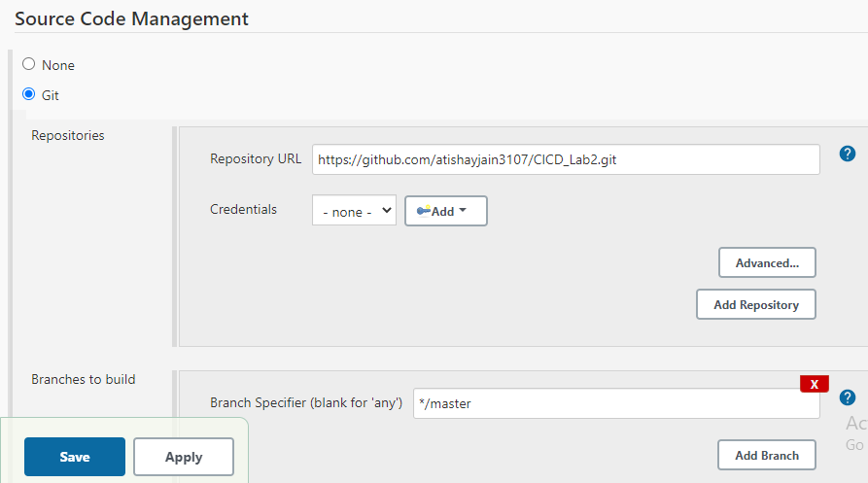

1. Now go to build tab and add the exact location of pom.xml file. If it’s inside a folder then, specify it as “{folder name}/pom.xml”
2. In goals and option section, run clean install sonar:sonar -Dsonar.host.url=http://localhost:9000 -Dsonar.analysis.mode=publish

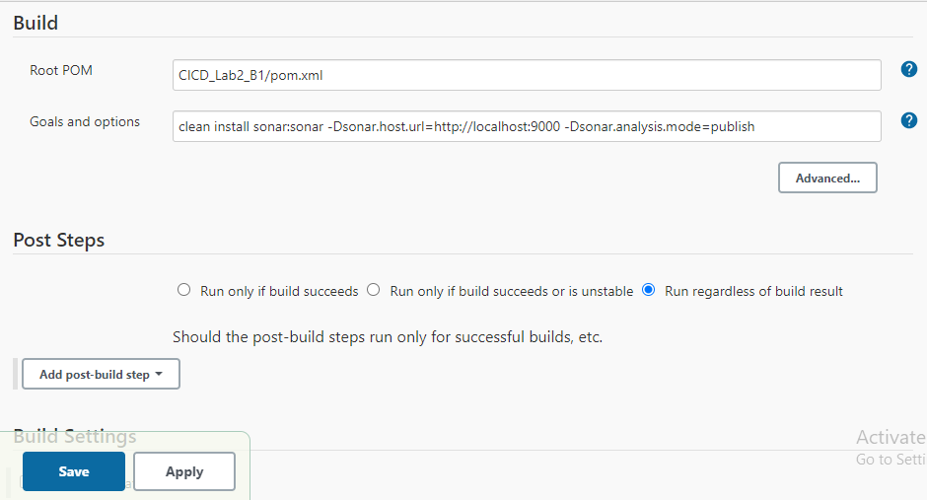

1. Now open http://localhost:9000/projects, you will find your maven project and vulnerabilities will be accessed

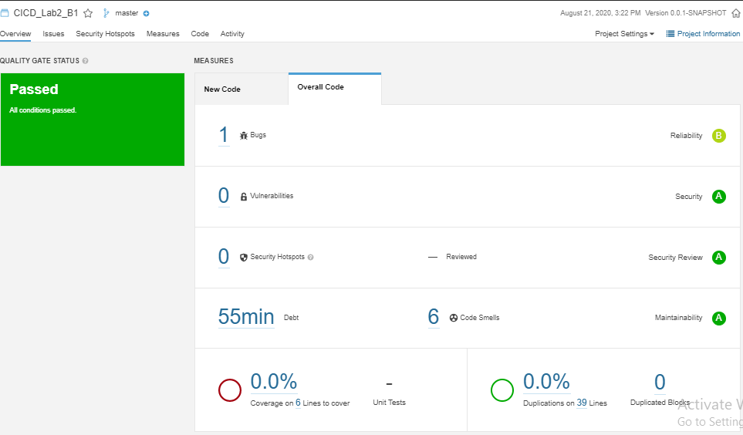

ATISHAY JAIN

500067694

R171218030

CSE, DEVOPS